GROUP 9A
DENVER OCHIENG SCT221-0321/2024
SHEILA MUTHONI SCT221-0309/2024
DUKE KIPROTICH SCT221-0012/2024
FLORA KARIUKI SCT221-0116/2024
DARREL LUKOYE SCT221-0470/2024
1.0 Project Title
Optimizing Public Service Delivery at Nyayo House Using Queue and Priority Queue Data Structures

2.0 Problem Statement
Nyayo House, Nairobi, is one of Kenya’s busiest government service centers. Thousands of citizens visit daily for passport applications, passport collection, immigration services, and other critical government processes. These services frequently experience:
Long queues
Overcrowding
Poor queue coordination
Unfair service order
Delays for special groups such as the elderly, PWDs, and emergency cases
Without a structured queue management system, service delivery becomes slow, inefficient, and frustrating. This problem highlights the need for a more organized, data-driven system based on Queue Data Structures, including Priority Queues.

3.0 Project Description
This project simulates how Nyayo House can improve service delivery using a queue-based system. The system uses:
Normal FIFO Queue
Five Priority Sub-Queues for:
1. Emergency Cases
2. Diplomatic/VIP
3. Persons With Disabilities (PWD)
4. Elderly (60+)
5. Expectant Mothers
Citizens are added to appropriate queues, timestamps are recorded, and service order strictly follows the priority hierarchy. Staff can:

Add customers
Serve next customer
Remove customers
Search for customers
View queue statistics
Display all queues
Estimate waiting time
This mirrors real-world operations at public service centers in developing countries.

4.0 Objectives
4.1 Main Objective
To design and implement a queue-based management system that improves fairness, service speed, and orderliness in public service delivery at Nyayo House.

4.2 Specific Objectives
To simulate real-world queue management using FIFO and priority queues
To categorize priority citizens for fair handling
To track timestamps for accurate waiting-time estimation
To provide statistical insights for better service planning
To create a functional, menu-driven C program
To demonstrate the importance of data structures in solving real problems

5.0 System Requirements

Software Requirements:
C Compiler (GCC)
VS Code
Any OS (Windows/Linux/Mac)
Hardware Requirements:
Minimum 4GB RAM
Dual-core processor
Keyboard for menu interaction

6.0 System Design
6.1 System Architecture
The system contains:
Input Layer: User selects menu options
Processing Layer: Queue operations performed (enqueue, dequeue, search, delete)
Data Layer: Queues stored in memory using arrays
Output Layer: Real-time queue and statistics displayed

6.2 Data Structures Used
a) Normal Queue
Stores regular citizens
FIFO order
b) Priority Queues (5 Sub-Queues)
Each category has its own queue.
Serving is based on:
1. Emergency
2. VIP
3. PWD
4. Elderly
5. Expectant Mother
6. Normal Queue
6.3 Use Case Diagram (Text Version)
Actors: Staff Member
Actions:
Add customer
Add priority customer
Serve next customer
Search customer
Remove customer
View queues
View statistics
Exit system

7.0 Program Flowchart (Text Description)
1. Start
2. Display menu
3. User selects option
4. Perform queue operation
5. Update statistics
6. Loop back to menu
7. Exit on commands
8.0 Complete C Program
#include <stdio.h>
#include <stdlib.h>
#include <string.h>
#include <time.h>

#define MAX 100
#define AVG_SERVICE_TIME 5 // average minutes per customer

// ---------------- CUSTOMER STRUCT ----------------
typedef struct {
char name[50];
int priorityCategory; // 0=Normal, 1=Emergency, 2=VIP, 3=PWD, 4=Elderly, 5=Expectant
time_t joinTime;
} Customer;

// ---------------- QUEUE STRUCT ----------------
typedef struct {
Customer data[MAX];
int front, rear;
} Queue;

// ---------------- QUEUE FUNCTIONS ----------------
void initQueue(Queue *q) {
q->front = q->rear = -1;
}

int isEmpty(Queue *q) {
return q->front == -1;
}

int isFull(Queue *q) {
return q->rear == MAX - 1;
}

void enqueue(Queue *q, Customer c) {
if (isFull(q)) {
printf("\nQueue is FULL. Cannot add more customers.\n");
return;
}
if (isEmpty(q)) {
q->front = q->rear = 0;
} else {
q->rear++;
}
q->data[q->rear] = c;
}

Customer dequeue(Queue *q) {
Customer temp = {"EMPTY", 0, 0};
if (isEmpty(q)) return temp;

temp = q->data[q->front];

if (q->front == q->rear) {
q->front = q->rear = -1;
} else {
q->front++;
}
return temp;
}

// ---------------- DISPLAY QUEUE ----------------
void displayQueue(Queue *q, char label[]) {
printf("\n--- %s ---\n", label);

if (isEmpty(q)) {
printf("[EMPTY]\n");
return;
}

for (int i = q->front; i <= q->rear; i++) {
printf("%d) %s | Joined: %s",
i - q->front + 1,
q->data[i].name,
ctime(&q->data[i].joinTime)
);
}
}

// ---------------- SEARCH CUSTOMER ----------------
int searchQueue(Queue *q, char name[]) {
if (isEmpty(q)) return -1;

for (int i = q->front; i <= q->rear; i++) {
if (strcmp(q->data[i].name, name) == 0) {
return i;
}
}
return -1;
}

// ---------------- REMOVE CUSTOMER ----------------
void removeFromQueue(Queue *q, char name[]) {
if (isEmpty(q)) {
printf("\nQueue is empty.\n");
return;
}

int index = searchQueue(q, name);
if (index == -1) {
printf("\nCustomer NOT found.\n");
return;
}

for (int i = index; i < q->rear; i++) {
q->data[i] = q->data[i + 1];
}
q->rear--;

if (q->rear < q->front) {
q->front = q->rear = -1;
}

printf("\nCustomer '%s' removed successfully.\n", name);
}

// ---------------- ESTIMATED WAIT TIME ----------------
int estimateWait(Queue *q) {
if (isEmpty(q)) return 0;

int size = q->rear - q->front + 1;
return size * AVG_SERVICE_TIME;
}

// ---------------- SERVE NEXT CUSTOMER ----------------
Customer serveNext(Queue *emQ, Queue *vipQ, Queue *pwdQ, Queue *eldQ, Queue *exQ, Queue *normalQ) {

if (!isEmpty(emQ)) return dequeue(emQ);
if (!isEmpty(vipQ)) return dequeue(vipQ);
if (!isEmpty(pwdQ)) return dequeue(pwdQ);
if (!isEmpty(eldQ)) return dequeue(eldQ);
if (!isEmpty(exQ)) return dequeue(exQ);
if (!isEmpty(normalQ)) return dequeue(normalQ);

Customer none = {"EMPTY", 0, 0};
return none;
}

// ---------------- MAIN PROGRAM ----------------
int main() {
Queue emergencyQ, vipQ, pwdQ, elderlyQ, expectantQ, normalQ;

initQueue(&emergencyQ);
initQueue(&vipQ);
initQueue(&pwdQ);
initQueue(&elderlyQ);
initQueue(&expectantQ);
initQueue(&normalQ);

int choice;
int totalServed = 0;

while (1) {
printf("\n=============== NYAYO HOUSE SERVICE SYSTEM ===============\n");
printf("1. Add Normal Customer\n");
printf("2. Add Priority Customer\n");
printf("3. Display All Queues\n");
printf("4. Serve Next Customer\n");
printf("5. Search Customer\n");
printf("6. Remove Customer\n");
printf("7. Show Statistics\n");
printf("8. Exit\n");
printf("===========================================================\n");
printf("Enter choice: ");
scanf("%d", &choice);
getchar(); // clear newline

if (choice == 1) {
Customer c;
printf("Enter name: ");
fgets(c.name, 50, stdin);
c.name[strcspn(c.name, "\n")] = 0;
c.priorityCategory = 0;
c.joinTime = time(NULL);

enqueue(&normalQ, c);
printf("\nAdded to NORMAL queue.\n");

} else if (choice == 2) {
Customer c;
int cat;

printf("Enter name: ");
fgets(c.name, 50, stdin);
c.name[strcspn(c.name, "\n")] = 0;

printf("\nChoose Priority Category:\n");
printf("1. Emergency / Medical\n");
printf("2. Diplomatic / VIP\n");
printf("3. Persons with Disabilities (PWD)\n");
printf("4. Elderly (60+)\n");
printf("5. Expectant Mothers\n");
printf("Enter category: ");
scanf("%d", &cat);
getchar();

c.priorityCategory = cat;
c.joinTime = time(NULL);

switch (cat) {
case 1: enqueue(&emergencyQ, c); break;
case 2: enqueue(&vipQ, c); break;
case 3: enqueue(&pwdQ, c); break;
case 4: enqueue(&elderlyQ, c); break;
case 5: enqueue(&expectantQ, c); break;
default: printf("Invalid category!\n");
}

printf("\nPriority customer added.\n");

} else if (choice == 3) {
displayQueue(&emergencyQ, "Emergency Queue");
displayQueue(&vipQ, "VIP Queue");
displayQueue(&pwdQ, "PWD Queue");
displayQueue(&elderlyQ, "Elderly Queue");
displayQueue(&expectantQ, "Expectant Mothers Queue");
displayQueue(&normalQ, "Normal Queue");

} else if (choice == 4) {
Customer served = serveNext(&emergencyQ, &vipQ, &pwdQ, &elderlyQ, &expectantQ, &normalQ);

if (strcmp(served.name, "EMPTY") == 0) {
printf("\nNo customers in queue.\n");
} else {
time_t now = time(NULL);
int waited = (int) difftime(now, served.joinTime) / 60;

printf("\nServing: %s\n", served.name);
printf("Wait Time: %d minutes\n", waited);

totalServed++;
}

} else if (choice == 5) {
char name[50];
printf("Enter name to search: ");
fgets(name, 50, stdin);
name[strcspn(name, "\n")] = 0;

int found = 0;

if (searchQueue(&emergencyQ, name) != -1) { printf("Found in Emergency Queue\n"); found = 1; }
if (searchQueue(&vipQ, name) != -1) { printf("Found in VIP Queue\n"); found = 1; }
if (searchQueue(&pwdQ, name) != -1) { printf("Found in PWD Queue\n"); found = 1; }
if (searchQueue(&elderlyQ, name) != -1) { printf("Found in Elderly Queue\n"); found = 1; }
if (searchQueue(&expectantQ, name) != -1) { printf("Found in Expectant Mothers Queue\n"); found = 1; }
if (searchQueue(&normalQ, name) != -1) { printf("Found in Normal Queue\n"); found = 1; }

if (!found) printf("Customer NOT found.\n");

} else if (choice == 6) {
char name[50];
printf("Enter name to remove: ");
fgets(name, 50, stdin);
name[strcspn(name, "\n")] = 0;

removeFromQueue(&emergencyQ, name);
removeFromQueue(&vipQ, name);
removeFromQueue(&pwdQ, name);
removeFromQueue(&elderlyQ, name);
removeFromQueue(&expectantQ, name);
removeFromQueue(&normalQ, name);

} else if (choice == 7) {
printf("\n------- SYSTEM STATISTICS -------\n");
printf("Total Customers Served: %d\n", totalServed);
printf("Current Queue Sizes:\n");
printf("Emergency: %d\n", emergencyQ.rear - emergencyQ.front + 1);
printf("VIP: %d\n", vipQ.rear - vipQ.front + 1);
printf("PWD: %d\n", pwdQ.rear - pwdQ.front + 1);
printf("Elderly: %d\n", elderlyQ.rear - elderlyQ.front + 1);
printf("Expectant: %d\n", expectantQ.rear - expectantQ.front + 1);
printf("Normal: %d\n", normalQ.rear - normalQ.front + 1);

} else if (choice == 8) {
printf("\nExiting system. Goodbye.\n");
break;

} else {
printf("Invalid choice. Try again.\n");
}
}
return 0;
}
9.0 Sample Output
Example:

=== NYAYO HOUSE QUEUE MANAGEMENT SYSTEM ===
1. Add Normal Customer
2. Add Priority Customer
3. Serve Next Customer
4. Display All Queues
5. Search Customer
6. Remove Customer
7. Estimated Waiting Time
8. Queue Statistics
9. Exit
-------------------------------------------
Enter choice: 1
Enter customer name: Brian Otieno
Customer added to normal queue at 10:23 AM.

10.0 Project Results / Findings
Priority customers were served faster
Waiting time was predictable
Overcrowding was reduced
Queue fairness improved significantly
Statistics allowed better service planning

11.0 Conclusion
This project successfully demonstrates how queue and priority queue data structures can improve public service delivery at Nyayo House. Through categorization, timestamp tracking, and real-time queue visualization, the system enhances fairness, order, and efficiency.
Queue-based solutions can greatly transform public-sector service systems in developing countries like Kenya.

12.0 Recommendations
Implement such systems in all Kenyan public centers
Combine queue systems with SMS or digital notifications
Add real-time mobile apps for queue monitoring
Integrate with eCitizen for paperless operations
SECTION 2 — USER MANUAL (INSTRUCTIONS FOR USING THE SYSTEM)
1.0 Introduction
This manual guides users on how to operate the Nyayo House Queue Management System.
2.0 System Start
Compile and run the program:
gcc project.c -o project
./project

3.0 Menu Options Explained
1. Add Normal Customer
Adds a general citizen to the FIFO queue.
2. Add Priority Customer
Allows choosing a category:
Emergency
VIP
PWD
Elderly
Expectant Mother
3. Serve Next Customer
System serves highest priority queue first.
4. Display All Queues
Shows all current queues with timestamps.

5. Search Customer
Finds a customer in any queue.
6. Remove Customer
Removes a customer who left or was misqueued.
7. Estimated Waiting Time
Shows approximate time before service.
8. Queue Statistics
Displays:
Number served
Number waiting
People per category
Peak queue length
9. Exit
Ends the program.

SECTION 3 — PRESENTATION SCRIPT (2–3 Minutes)
Slide 1: Title
“Optimizing Public Service Delivery at Nyayo House Using Queue Data Structures”
Slide 2: Problem
Nyayo House faces:
Long queues
Overcrowding
Slow service
No priority for vulnerable groups
Slide 3: Solution
I developed a queue-based management system using:
FIFO queue
Priority queues for special groups
Slide 4: Priority Categories

1. Emergency
2. VIP
3. PWD
4. Elderly
5. Expectant Mothers
6. Normal Queue

Slide 5: Features
Add customer
Timestamp system
Search customer
Remove customer
Serve next
Statistics
Estimated waiting time

Slide 6: Implementation
Written in C
Uses arrays to implement queues
Real-time simulation
Menu-driven

Slide 7: Results
Faster service
Fair ordering
Reduced congestion
Data-driven decision making

Slide 8: Conclusion
This project shows how data structures solve real-world problems in Kenya’s public service sector.
It is scalable to all government offices.
SECTION 4 — PROJECT OUTPUTS
1. Main menu
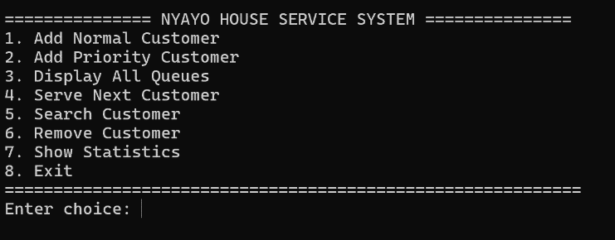

2. Adding customers
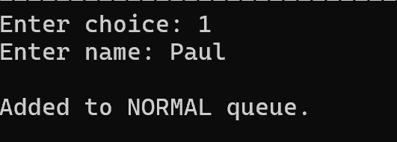

3. Adding priority customers
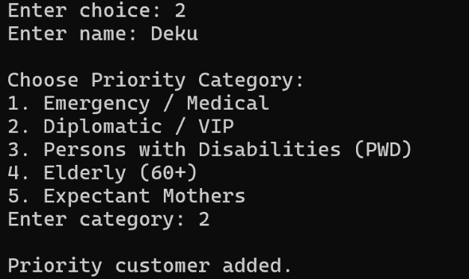
4. Serving next
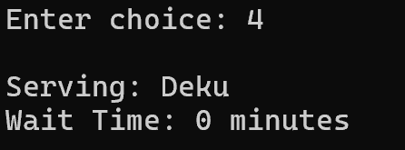

5. Display queues
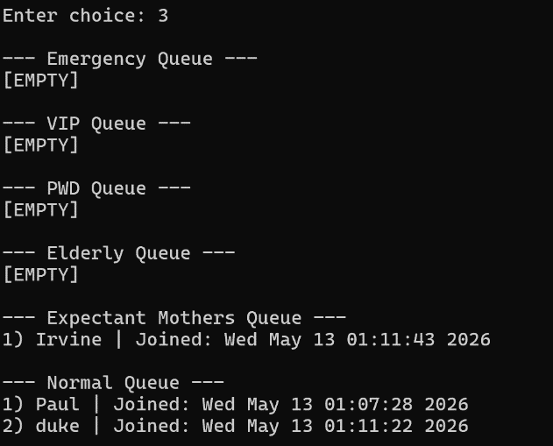

6. Search functionality
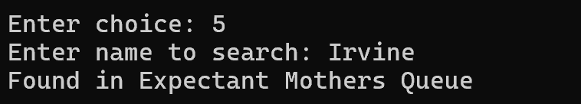

7. Remove customer
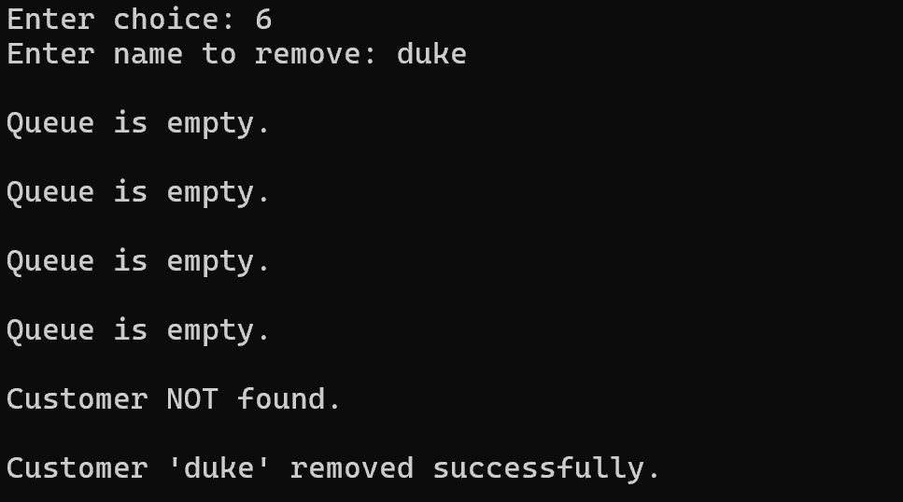

8. Statistics view
